They’re Back…
Summer Splash Facials

Aromatic and Healing Facials
Glow with Vitality and Health
Enjoy a 60 Minute Facial only $60 - Normally - $75
Prices Good thru 7/31/17
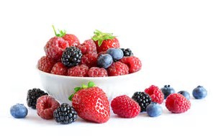
.
The Berry Blast Antioxidant Facial: Feed your skin with nature’s top three antioxidant rich fruits: Strawberries, Blackberries and Blueberries. The powerful antioxidants and a blend of Chinese herbs will increase your defense against free radical damage while providing calming and anti-inflammatory agents at the same time.

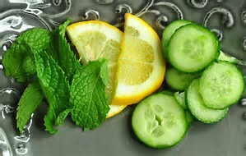
The Calming - Cooling - Hydrating Facial:
The ultimate skin pick-me-up. Refreshing and cooling Cucumbers and Mint provide will wake up and stimulate the skin’s tissue, providing potent anti-oxidant support, all while toning and increasing hydration levels.

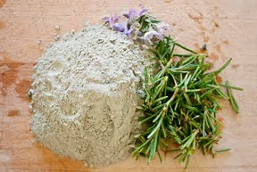
The Detox Facial: The Purify Cleanser will dissolve sebum and tighten pores and speed the healing of blemishes. Paired with an anti-bacterial, stimulating French green clay and Rosemary mask to speed the healing of blemishes and calm the skin. Pure, fresh and clean.

Enjoy your favorite summer cleanser at a summer splash price!!
10% OFF
Strawberry Gel Cleanser
Lemon Cream Cleanser
Lemon Cream Scrub

Summer is also wedding season. Be sure to ask about our Customized Bridal Facials

